**BP315 Business Sub-Process Design Document**

**Asset Retirement**

**Supply Chain Management**

**SAP PM**

Table of Contents

1 Overview 3

1.1 Change History 3

1.2 RASCI 3

1.3 Approval Detail 3

1.4 Other Related Documents 3

2 Business Process Overview 4

2.1 High level requirements 4

2.2 Key Value Drivers for the Business Process 5

2.3 Leading Practice Inputs 5

3 Business Sub-Process Description 5

3.1 Business Sub-Process diagram 6

4 Sub Process Activities 6

4.1 Activity List 6

4.2 Inbound Communication 7

4.3 Outbound Communication 8

4.4 Test Conditions 8

5 Sub-Process Variation 8

5.1 Business Unit Led 8

5.2 Geography/Legal Entity Led 9

6 Role Definition & Organisational Impact 9

6.1 Role/Skill Class Inventory 9

6.2 Role Summary 9

6.3 Organizational Impact 10

7 Process Fitness & Gap Analysis 10

7.1 Process Fitness 10

7.2 Gap Analysis 10

8 RICEFW 11

8.1 Reports 11

8.2 Interfaces (Inbound / Outbound) 11

8.3 Conversions 12

8.4 Enhancements 12

8.5 Forms 12

8.6 Workflows 13

9 Integration Points 14

9.1 Integration Issues 14

9.2 Other issues 14

# Overview

The retirement transaction is the removal of an asset or part of an asset from the asset portfolio. The retirement of an asset could be either sale of asset or scrapping. An organization decides to retire an asset if the asset is no longer required or if it is in bad condition.

## Change History

|  |  |  |  |  |
| --- | --- | --- | --- | --- |
| Ver. | Date | Summary of Changes | Author | Transport Number |
| 1 | 06/12/2019 | Initial Draft | Rishabh Rastogi |  |
| 2 | 13/02/2020 | Document updated | Rishabh Rastogi |  |

## RASCI

|  |  |  |  |
| --- | --- | --- | --- |
| RASCI | Role | Name | Phone |
|  |  |  |  |
|  |  |  |  |
|  |  |  |  |

R: Responsible; A: Accountable; S: Support; C: Contribute; I: Information;

## Approval Detail

|  |  |  |  |
| --- | --- | --- | --- |
| Review # | Date | Name & Position of Approver | Signature |
|  |  |  |  |
|  |  |  |  |

## Other Related Documents

<Please insert links/references to related documents (issues, data entities, etc.)>

|  |  |
| --- | --- |
| Related Document | Comment |
|  |  |
|  |  |
|  |  |
|  |  |

# Business Process Overview

The retirement transaction is the removal of an asset or part of an asset from the asset portfolio. The retirement of an asset could be either sale of asset or scrapping. An organization decides to retire an asset if the asset is no longer required or if it is in bad condition.

The asset retirement transaction meets the following organizational requirements

Elimination of the book value of the asset which is disposed off. Also, de-activating of the asset master record to ensure that the asset is no longer in use in the system

Recording of revenue earned because of sale of asset (if any)

Recording of resulting gain or loss on account of sale of asset

Depending on organizational considerations, or the business transaction which leads to the retirement, following are the types of retirement:

Asset sale with revenue (posting to customer)

Asset sale with revenue (posting to clearing account)

Asset scrapping – no revenue earned.

Inter-company transfer (an asset is sold to an affiliated company)

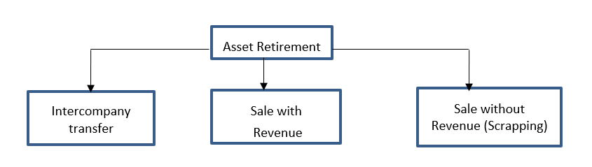

**Retirement Without Revenue/Scrapping**

When the asset is no longer economically profitable and it cannot be sale, transferred to other location or repaired and posting higher cost to company, it is retired without revenue. The process is called scrapping. During the retirement posting no gain or loss occurred in system and the system does not create any revenue.

## High level requirements

Equipment is not generating any revenue

Equipment is to be scrapped as per manufacturer guidelines.

It is not economically profitable to repair the asset.

## Key Value Drivers for the Business Process

Asset is to be retired from productive use

## Leading Practice Inputs

<Start bulleted text here – leave one character space after the bullet>

# Business Sub-Process Description

Following activities need to be perform while retiring asset:

**Find equipment linked to asset:** Equipments are the technical objects in Plant maintenance. All the maintenance activities are performed at equipment level. After the Asset to be retired is identified, the equipment associated with the asset should also be deleted so that no further maintenance activity is performed.

**Find and close linked notifications:** After getting the details of equipment, all the associated transactional data is to be removed. The orders and notifications are crucial data for maintenance. When the asset is retired, all the active notifications and orders should be closed and deleted to prevent any further maintenance.

**Set delete status to notification:** Deleting notification will stop all the planned maintenance activities. The notification is set to deleted and its status is updated to DLFL.

**Find and close linked Orders:** the maintenance work is performed after the order is released. Order is used for the actual execution of the tasks. All the required material and labour along with the tasks are given in the order. Scrapping asset should ensure that all the open order should be closed and deleted to prevent any further maintenance.

**Set delete status to order:** The execution of actual maintenance depends on the start date and tasks to be performed. Before disposing asset, all the orders should be deleted. On deleting the order, its status is updated to DLFL.

**Find linked measuring point/counter:** Measuring point and counters are used to record the readings of the equipment. This reading is the basis for scheduling performance based maintenance activity.

**Delete Assigned measuring point/counter:**  the measuring points associated should be deactivated to stop recording any further reading for the equipment.

**Find Equipment Task List:** Task list provide maintenance workers the list and sequence of tasks that need to be performed while doing maintenance activity. SAP defined three kinds of task lists i.e. General task list, Equipment task list and Functional location task list. Equipment task list represents the tasks that are applicable to an equipment only.

**Set Deletion flag to task list:** When decommissioning the equipment all the task list that are specific to that equipment i.e. equipment task list needs to be deleted.

**Find linked Maintenance Plan:** Maintenance plans defines the interval at which the maintenance should be performed. This interval is determined based on either time or performance or both. The equipment can be maintained on a regular interval like every 3 month or can be maintained when reaching a specified performance like every 10000 kilometres. This is the basis of scheduling the dates of maintenance. Before decommissioning the asset, the maintenance plan must be deleted so that no further orders are scheduled.

**Set Deletion flag to Maintenance Plan:** Delete the maintenance plan. It will set the status as Deletion Flag set.

**Dismantle Equipment from superior functional location or equipment:** After all the associated data is deactivated or delete, now the equipment can be dismantled from its installed location.

**Set delete status to equipment:** Set the delete status to the equipment. This will prevent any further maintenance for the equipment. A status DLFL will be set for the equipment.

**Retire Asset:** After all the data for plant maintenance is deleted, Asset Accountant can retire the asset. The business will now decide whether to sale the equipment, use it in other facility or scrap without any revenue.

## Business Sub-Process diagram

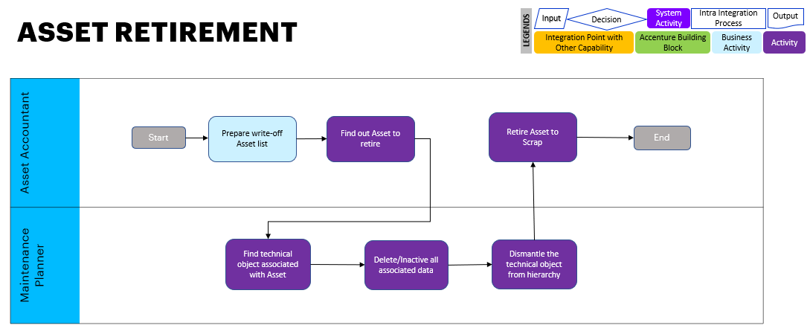

# Sub Process Activities

## Activity List

It maps to the BP317, Activity definition document if applicable for the project & also has references in the process/sub process diagram.

|  |  |  |  |  |
| --- | --- | --- | --- | --- |
| Name | Description | Fiori App | Roles involved | Regulatory /Other Controls |
| Find equipment linked to asset | Find the equipment linked to asset | Display Equipment | Maintenance Planner |  |
| Find and close linked notifications | Close relate notifications | Change Notifications | Maintenance Planner |  |
| Set delete status to notification | Set delete status to notification | Change Maintenance Notification | Maintenance Planner |  |
| Find and close linked Orders | Find and close linked Orders | Change PM Orders | Maintenance Planner |  |
| Set delete status to order | Set delete status to order | Change Maintenance Order | Maintenance Planner |  |
| Find linked measuring point/counter | Find linked measuring point/counter | Change Equipment | Maintenance Planner |  |
| Delete Assigned measuring point/counter | Delete Assigned measuring point/counter | Change Equipment | Maintenance Planner |  |
| Find Equipment Task List | Find Equipment Task List | Change Equipment Task list | Maintenance Planner |  |
| Set Deletion flag to task list | Set Deletion flag to task list | Change Equipment Task list | Maintenance Planner |  |
| Find linked Maintenance Plan | Find linked Maintenance Plan | Scheduling Overview | Maintenance Planner |  |
| Set Deletion flag to Maintenance Plan | Set Deletion flag to Maintenance Plan | Change Maintenance Plan | Maintenance Planner |  |
| Dismantle Equipment from superior functional location or equipment | Dismantle Equipment from superior functional location or equipment | Equipment Installation and Dismantle | Maintenance Technician |  |
| Set delete status to equipment | Set delete status to equipment | Change Equipment | Maintenance Planner |  |
| Retire Asset | Retire Asset | Post Asset Retirement- By Scrapping | Asset Accountant |  |

## Inbound Communication

The Inbound Communication needs to be specifically documented for the client specific situation, like interfacing with external systems, workflow, form & Medium of communication.

<Enter text here>

<Start bulleted text here – leave one character space after the bullet>

|  |  |  |  |  |
| --- | --- | --- | --- | --- |
| Activity | Type (email, form, handoff, etc) | Automatic/Manual | Source | Description |
|  |  |  |  |  |
|  |  |  |  |  |

## Outbound Communication

The Outbound Communication needs to be specifically documented for the client specific situation, like interfacing with external systems, workflow, form & Medium of communication.

|  |  |  |  |  |
| --- | --- | --- | --- | --- |
| Activity | Type (email, form, handoff, etc) | Automatic/Manual | Source | Description |
|  |  |  |  |  |
|  |  |  |  |  |

## Test Conditions

This section captures Test conditions for this sub process for the any specific client requirements. Generic test conditions for this sub process will be within the AAES test scripts.

<Enter text here>

<Start bulleted text here – leave one character space after the bullet>

|  |  |  |
| --- | --- | --- |
| Number | Test Condition – Action | Expected Result |
|  |  |  |
|  |  |  |

# Sub-Process Variation

<Enter text here>

<Start bulleted text here – leave one character space after the bullet>

## Business Unit Led

None

## Geography/Legal Entity Led

None

# Role Definition & Organisational Impact

The content in this section will serve as input for the training and performance support team’s deliverables.

<Enter text here>

<Start bulleted text here – leave one character space after the bullet>

## Role/Skill Class Inventory

|  |  |  |
| --- | --- | --- |
| Role | Skills | Knowledge |
|  |  |  |
|  |  |  |
|  |  |  |

## Role Summary

|  |  |  |
| --- | --- | --- |
| Role | List of Steps | Fiori App |
| Maintenance Planner | Find equipment linked to asset | Display Equipment |
| Maintenance Planner | Find and close linked notifications | Change Notifications |
| Maintenance Planner | Set delete status to notification | Change Maintenance Notification |
| Maintenance Planner | Find and close linked Orders | Change PM Orders |
| Maintenance Planner | Set delete status to order | Change Maintenance Order |
| Maintenance Planner | Find linked measuring point/counter | Change Equipment |
| Maintenance Planner | Delete Assigned measuring point/counter | Change Equipment |
| Maintenance Planner | Find Equipment Task List | Change Equipment Task list |
| Maintenance Planner | Set Deletion flag to task list | Change Equipment Task list |
| Maintenance Planner | Find linked Maintenance Plan | Scheduling Overview |
| Maintenance Planner | Set Deletion flag to Maintenance Plan | Change Maintenance Plan |
| Maintenance Technician | Dismantle Equipment from superior functional location or equipment | Equipment Installation and Dismantle |
| Maintenance Planner | Set delete status to equipment | Change Equipment |
| Asset Accountant | Retire Asset | Post Asset Retirement- By Scrapping |

## Organizational Impact

|  |  |  |  |  |
| --- | --- | --- | --- | --- |
| Reference # | Impact Description | Impact (H/M/L) | Impact Type | Impacted Groups |
|  |  |  |  |  |
|  |  |  |  |  |
|  |  |  |  |  |

# Process Fitness & Gap Analysis

<Enter text here>

<Start bulleted text here – leave one character space after the bullet>

## Process Fitness

|  |  |  |  |  |
| --- | --- | --- | --- | --- |
| Req ID | Short Description | Long Description | Req. Type | Accenture Reusable Assets |
|  |  |  |  |  |
|  |  |  |  |  |

## Gap Analysis

|  |  |  |  |  |  |  |
| --- | --- | --- | --- | --- | --- | --- |
| Country/ Region/ Business Impacted | Gap Description | Legal Req. (Y/N) | Magnitude of Impact (L/M/H) | Solution Type | RICEFW No. | Ref. to Req. id. |
|  |  |  |  |  |  |  |
|  |  |  |  |  |  |  |

# RICEFW

<Enter text here>

<Start bulleted text here – leave one character space after the bullet>

## Reports

|  |  |  |  |  |  |
| --- | --- | --- | --- | --- | --- |
| Client XYZ  RICEFW # | Report Description | Complexity (H/M/L) | Comments | Use from myConcerto/ARTL (New/Rework/Rep) | Ref # from RICEFW inventory |
|  |  |  |  |  |  |
|  |  |  |  |  |  |
|  |  |  |  |  |  |

## Interfaces (Inbound / Outbound)

|  |  |  |  |  |  |
| --- | --- | --- | --- | --- | --- |
| Client XYZ  RICEFW # | Interface Description | Complexity  (H/M/L) | Comments | Use from myConcerto/ARTL (New/Rework/Rep) | Ref # from RICEFW inventory |
|  |  |  |  |  |  |
|  |  |  |  |  |  |

## Conversions

This section to be completed by the Process Team with assistance from the Master Data Management Team

|  |  |  |  |  |  |
| --- | --- | --- | --- | --- | --- |
| Client XYZ  RICEFW # | Conversion Description | Complexity  (H/M/L) | Comments | Use from myConcerto/ARTL (New/Rework/Rep) | Ref # from RICEFW inventory |
|  |  |  |  |  |  |
|  |  |  |  |  |  |

## Enhancements

|  |  |  |  |  |  |
| --- | --- | --- | --- | --- | --- |
| Client XYZ  RICEFW # | Enhancement Description | Complexity  (H/M/L) | Comments | Use from myConcerto/ARTL (New/Rework/Rep) | Ref # from RICEFW inventory |
|  |  |  |  |  |  |
|  |  |  |  |  |  |

## Forms

|  |  |  |  |  |  |
| --- | --- | --- | --- | --- | --- |
| Client XYZ RICEFW # | Form Description | Complexity (H/M/L) | Comments | Use from myConcerto/ARTL (New/Rework/Rep) | Ref # from RICEFW inventory |
|  |  |  |  |  |  |
|  |  |  |  |  |  |

## Workflows

|  |  |  |  |  |  |
| --- | --- | --- | --- | --- | --- |
| Client XYZ RICEFW # | Workflow Description | Complexity (H/M/L) | Comments | Use from myConcerto (New/Rework/Rep) | Ref # from RICEFW inventory |
|  |  |  |  |  |  |
|  |  |  |  |  |  |

# Integration Points

Generic Integration touch points have been highlighted in this section. It covers dependencies or prerequisites arising from other processes or sub processes. This information should lead to cross functional discussions between different work streams to sort out the interdependencies.

<Enter text here>

<Start bulleted text here – leave one character space after the bullet>

## Integration Issues

|  |  |  |  |  |
| --- | --- | --- | --- | --- |
| Issue # | Issue Description | Impact | Status | Resolution |
|  |  |  |  |  |
|  |  |  |  |  |

## Other issues

|  |  |  |  |  |
| --- | --- | --- | --- | --- |
| Issue # | Issue Description | Impact | Status | Resolution |
|  |  |  |  |  |
|  |  |  |  |  |

#### Revision History

|  |  |  |  |
| --- | --- | --- | --- |
| Date | Version | Description | Author |
| DD/MM/YYYY |  |  |  |
|  |  |  |  |
|  |  |  |  |